**Genesis Project User Interface**

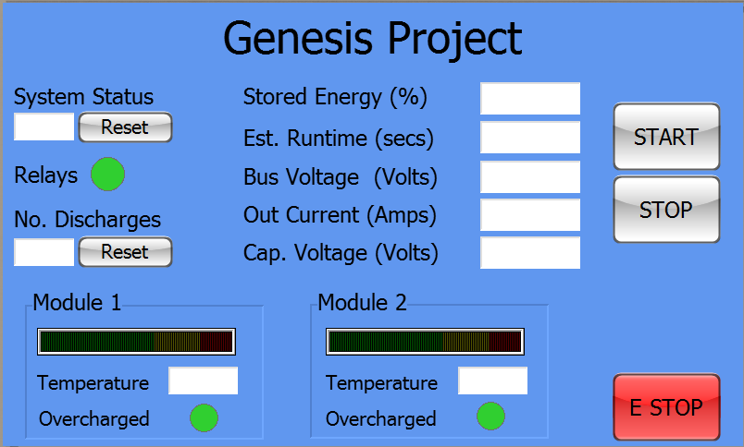

Overall System Monitoring

* Monitor the status of the system
* Check status of the system relays
* Track number of discharges
* Show the energy stored in the capacitors
* Show the estimated runtime
  + Can be based on a given load
* Voltage on the bus
* Current output
* Voltage of the capacitors

Module Overview

* Gauge showing the voltage level
* Temperature
* Overcharged status

System Control

* Start the system
* Stop the system
* Emergency Stop the system